You are the consultant in charge of the fast track area. You are asked to review a 21yo female who presents with pre-syncope. Please take a history from the patient and give advice about further investigations and management.
The patient’s ECG is attached.

Domains being examined
• Medical expertise
• Prioritisation and decision making
• Communication

Thank you again to LITFL for this ECG!
http://cdn.lifeinthefastlane.com/wp-content/uploads/2009/12/Brugada-type-3.JPG

Information for the actor (patient)

Hx
• 21yo female
• at work stacking shelves in woolworths when you began to feel light headed and felt you might faint
• possibly had palpitations but cannot be sure
• DID HAVE CHEST PAIN, felt mildly short of breath
• pre-syncope lasted for 45 seconds but still has ongoing mild chest pain and shortness of breath
• advised by employer to present to ED for assessment
• you do feel palpitations from time to time
• has fainted once before age 18 but this was when she used to have heavy periods
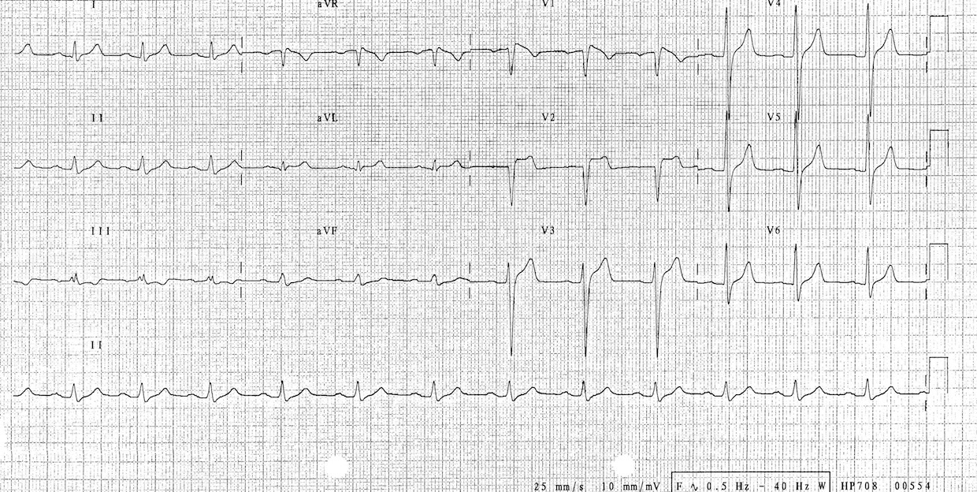
• recent long haul flight from USA where she went on a 2 week holiday
• on OCP
• mild left calf swelling/pain but thought this was because of a pre-existing netball injury

B/G:
• childhood asthma but no exacerbations since age
• nil else —> has never had an ECG
• meds: ‘nothing’ (only say OCP if specifically asked)
• NKDA
• non-smoker, social etch
• Family Hx only give on specific questioning:
◦ no family Hx of sudden cardiac death,
◦ mother had a PE during pregnancy

Extra-instructions
• if the candidate has failed to reach a differential Dx by 5mins, ask ‘what do you think is wrong with me’ +/- ‘what will happen from here'

Medical expertise
• differential diagnosis:
◦ brugada as a possible diagnosis —> based on ECG and presyncope
◦ PE based on HPI and ECG
• clear explanation about ECG changes and their implications, DDx:
- could be brugada
- could be PE
- could be a congenital cardiac issue
- could be nothing!
• asks about high risk features of brugada syndrome :
1. family members have same ECG
2. syncope
3. family Hx of SCD
4. irregular noctural respirations
5. VT on EP study
• 2 lines of Ix
◦ PE: d-dimer, CTPA
◦ if no PE —> need to assess for brugada
◦ then discuss/justify in-patient vs outpatient assessment

Prioritisation and decision making
• identification of potentially unwell patient who needs further Ix and likely admission
Communication
• simple explanations of pathologies and the ways in which are investigated

